An Evening with Tony Cottee (Sky Sports),
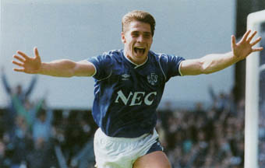
Including never before seen private memorabilia.

Maghull Town Hall
Tuesday 29th June 2010. 7pm Prompt
In Aid Of
The Everton Collection Charitable Trust
Registered charity number 1109480
http://www.evertoncollection.org.uk/home

Tony Cottee will be appearing at Maghull Town Hall, this will be an opportunity to see memoribilia never been put on display before. Tony will have with him the 6 balls and the boots he wore that he scored his famous hat-tricks for Everton Football Club including his debut hat-trick against Newcastle United on 27th August 1988. Re-live Tony’s goals on the big screen. Tony Cottee became the most expensive player to be signed by a British club when on 2 August 1988 he joined Everton in a £2.2 million deal.
Throughout Tony’s career he kept every payslip, every contract and every programme from every game he played. You will be the 1st to see private photographs of Tony throughout his career. Tony made 184 appearances for Everton scoring 72 goals. 7 England caps and playing 8 times for England under 21 side. The evening will also include surprise guests plus comedian Mark Langley and a Chicken in the basket supper.

The evening is right in the middle of The World Cup and we are also going to celebrate the fact.

Limited Tickets are on sale @ £20 per person or buy Table of 10 for £200.
VIP tables of 10 available at £250, includes framed table photo with Tony Cottee.
All profits with go to The Everton Collection Charitable Trust. The evening will be videoed so here is your chance to be part of The Everton Collection and Tony Cottee footage.
Tony’s Hat Trick balls which will be on display include.
Jan 15 1994 A Cottee (h) 6-2 Swindon Town League
Aug 21 1993 A Cottee (h) 4-2 Sheffield United League
Oct 05 1991 A Cottee (h) 3-1 Tottenham Hotspur League
Jan 22 1991 A Cottee (4) (h) 4-1 Sunderland ZDS Cup
Sep 25 1990 A Cottee (a) 5-0 Wrexham League Cup
Aug 27 1988 A Cottee (h) 4-0 Newcastle United League

Ring for tickets
Matty 07963397837
Tony 07542916040

